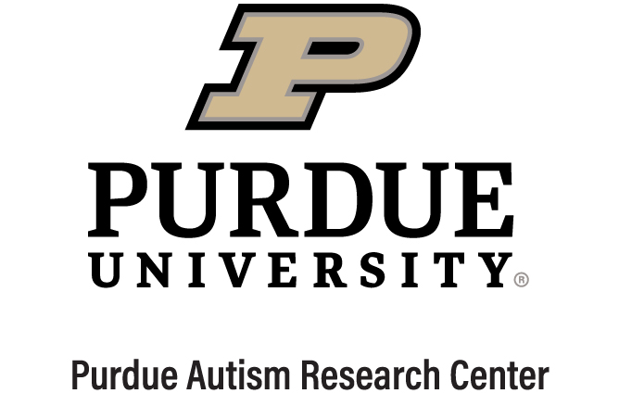
Purdue Autism Research Center Membership Application: Student Affiliate
Thank you for your interest in affiliating with the Purdue Autism Research Center. PARC’s mission is to support individuals with autism and other neurodevelopmental disabilities by (1) advancing scientific discovery through interdisciplinary research that bridges cell cultures to community cultures, (2) mentoring the next generation of thought leaders, including scientists and practitioners, and (3) partnering with self-advocates, families, and communities to translate scientific discovery for lasting societal impact.
Membership is open to Purdue faculty, students and allies, and alumni who have personal or professional interests related to PARC’s mission, and who have attended at least one PARC event within the past year. PARC affiliates are invited to a variety of events throughout the year and are eligible to apply for center funding.
Please e-mail this completed application as a word document to PARCAwards@purdue.edu. Thank you!
Name:
Title:
Anticipated Degree:
Anticipated Graduation:
PARC Faculty Mentor:
(not required)
E-mail:
Professional Twitter:
Professional Instagram:
Please describe your personal and/or professional interests in PARC (2-3 sentences). This information will not be shared beyond the PARC Leadership team.
Please list at least one PARC event you have attended in the past year, including seminars and conferences.
Please copy and paste your headshot here. This headshot may be included on the PARC web site and social media accounts.

